SOUTHERN CALIFORNIA FAIR BETTY HILL MEMORIAL
HORSE SHOW and GYMKHANA
Show Date October 1st, 2017 -- Entry Deadline September 28th, 2017
State Fair “Best of Show” Qualifier and 4-H State Classic Qualifier
* * * Do separate entry form for EACH horse & rider combination * * *
Entrant’s Name: ______________________________________Phone______________________
Address: _____________________________________City/Zip ____________________________
Age (on December 31, 2017): _______Birth date: ________Horse’s Name: __________________
Club Name______________________________________ County: ______________________
Each 4-H Member must bring in one $10 sponsor: Name of Sponsor:
Sponsors will be announced throughout the show.
Must submit the following forms with entry. (Horse must be ID’d for minimum 60 days.)
1) Horse ID (http://tinyurl.com/RivHorseID)
2) Lease Agreement (if applicable) (http://tinyurl.com/4HEquineLease)
3) Waiver of Liability (http://tinyurl.com/RivWaiver)
4) Treatment & Health Forms (http://tinyurl.com/health4H)
Participants, leaders and parents are expected to adhere to the 4-H Code of Conduct (http://tinyurl.com/coedall) and the Riverside County Horse Show rules (http://tinyurl.com/Rivrules).
ASTM/SEI approved helmets and boots required in all riding classes.
4-H or FFA uniform with boots required in showmanship classes.
My child,____________________________________, has my permission to participate in the Riverside County SoCal Fair, Betty Hill Memorial Horse Show on October 1st, 2017. I understand that while at this event my child is expected to adhere to the 4-H Code of Conduct and Riverside County Horse Show rules.

Parent/Guardian name (print) Parent/Guardian signature Date

I have read the 4-H Code of Conduct and the Riverside County Horse Show rules and agree to abide by them. I verify that I am 9 years old or older, have been enrolled in the 4-H or F.F.A. horse project for at least 60 days, and that I have owned or leased the horse that I am riding at this event for at least 60 days.

Entrant’s name (print) Entrant’s signature Date

As the 4-H or F.F.A. horse leader in the 4-H Club or F.F.A. chapter, I certify that this youth has been enrolled in the Horse & Ponies project for at least 60 days and that the horse being shown has been ID’d as the member’s project horse for at least 60 days.

4-H or FFA Leader’s name (print) 4-H or FFA Leader’s signature Date

Entry Fees: number of classes entered x $4.99 = $
Required Sponsorship for each 4-H member of $10.00 $10.00
Total Entry Fees $
Please make checks payable to Riverside County 4-H. $25 fee for returned checks!!

Mail to: Lynn Warren, 9070 Whispering Pines Rd. Cherry Valley, CA 92223
lynnwarren4h@gmail.com (951) 845-7730

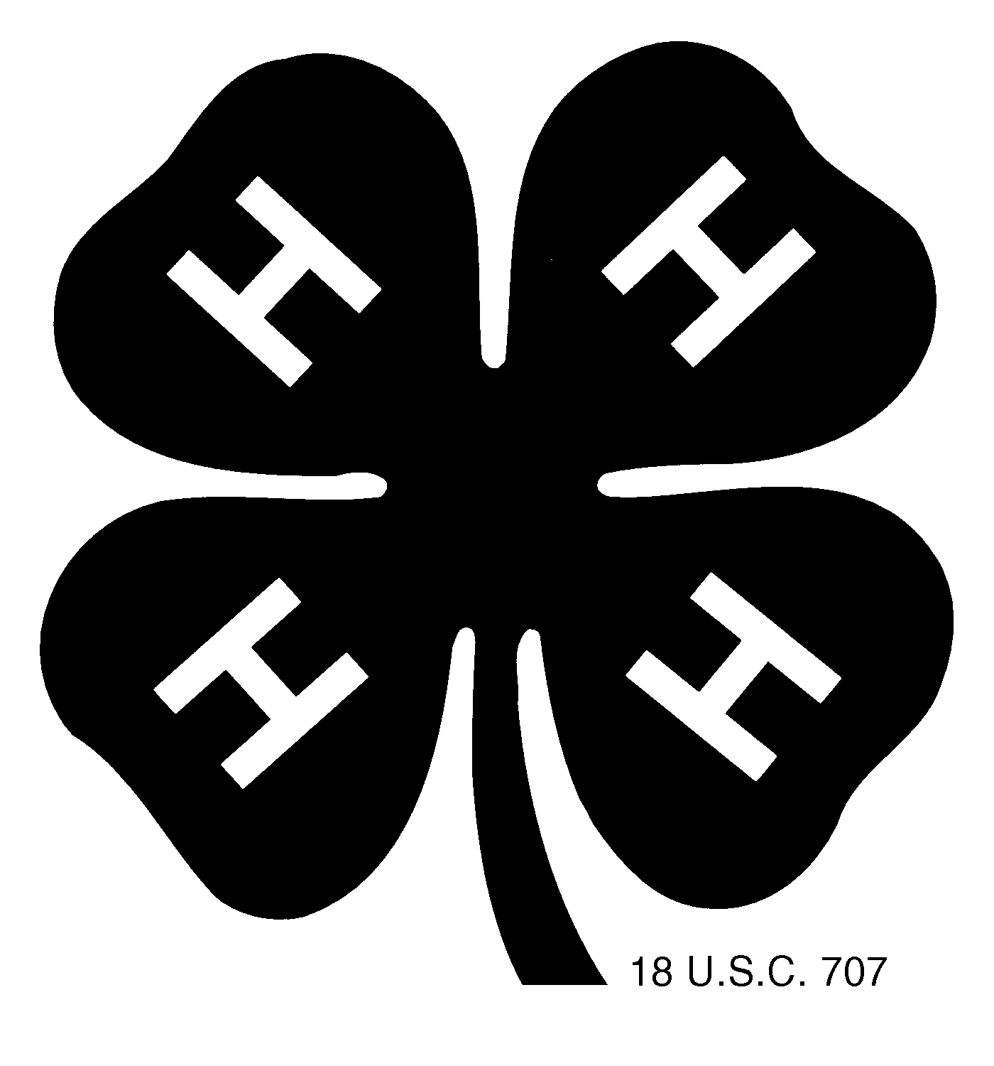
SOUTHERN CALIFORNIA FAIR
BETTY HILL MEMORIAL HORSE SHOW and GYMKHANA

Sunday October 1st, 2017 at the Perris Fair Grounds
Safety Meeting at 7:45 am Show starts at 8:00 am

English Classes |  |  | 37 | Western Horsemanship | W/J Novice
1 | Hunter Hack Ground Poles | W/T Novice | 38 | Western Horsemanship | W/J Green
2 | Hunter Hack Ground Poles | W/T Green | 39 | Western Horsemanship | Pony
3 | English Equitation | W/T Novice | 40 | Western Horsemanship | Junior
4 | English Equitation | W/T Green | 41 | Western Horsemanship | Senior/FFA
5 | English Equitation | Pony | 42 | Western Pleasure | W/J Novice
6 | English Equitation | Junior | 43 | Western Pleasure | W/J Green
7 | English Equitation | Senior/FFA | 44 | Western Pleasure | Pony
8 | English Horsemanship (pattern) | W/T Novice | 45 | Western Pleasure | Junior
9 | English Horsemanship (pattern) | W/T Green | 46 | Western Pleasure | Senior/FFA
10 | English Horsemanship (pattern) | Pony | 47 | Country Pleasure - W/J OK | Open
11 | English Horsemanship (pattern) | Junior | 48 $ | Western Obedience (3 gaits) | Open
12 | English Horsemanship (pattern) | Senior | 49 #$ | Western Riding (3 gaits) | Open
13 | English Pleasure | W/T Novice | 50 #$ | Clover Reining (3 gaits) | Open
14 | English Pleasure | W/T Green | Trail classes judged open card
15 | English Pleasure | Pony | 51 | Walk/Jog Trail | Novice
16 | English Pleasure | Junior | 52 | Walk/Jog Trail | Green
17 | English Pleasure | Senior/FFA | 53 | Trail | Pony
18 | Eng Country Pleasure-W/T OK | Open | 54 | Trail | Junior
19 | Hunter Under Saddle | W/T Open | 55 | Trail | Senior/FFA
20 | Hunter Under Saddle (3 gaits) | Open | 56 | Mini Horse Trail Obstacles | Open
21 $ | English Obedience (3 Gaits) | Open | Miniature Horse Classes
22 #$ | Clover English Eq. (3 gaits) | Open | 57 | Mini Horsemanship | Open
15 minute break |  |  | 58 | Mini Horse Hunter | Open
23 | Showmanship (E/W) | W/T Novice | 59 | Mini Horse Jumpers | Open
24 | Showmanship (E/W) | W/T Green | 60 | Mini Horse Pole Bending | Open
25 | Showmanship (E/W) | Pony & Mini | Gymkhana – not to start before 3:00 p.m.
26 | Showmanship (E/W) | Junior | 61 | Single Stake Race | Junior
27 | Showmanship (E/W) | Senior/FFA | 62 | Single Stake Race | Senior
28 # | Caressa Hill Showmanship  Riverside County members only | Open | 63 | Washington Pole Bending | Junior
 |  |  | 64 | Washington Pole Bending | Senior
29 # | Bareback eq.(E/W) W/T OK | Junior | 65 | Bi-Rangle | Junior
30 # | Bareback eq.(E/W) W/T OK | Senior/FFA | 66 | Bi-Rangle | Senior
31 | Pleasure Driving | Open | 67 | Quad Rangle | Junior
30 Minute Lunch Break |  |  | 68 | Quad Rangle | Senior
Western Classes |  |  | 69 | Speed Barrels | Junior
32 | Western Equitation | W/J Novice | 70 | Speed Barrels | Senior
33 | Western Equitation | W/J Green | 71 | Cloverleaf Barrels | Junior
34 | Western Equitation | Pony | 72 | Cloverleaf Barrels | Senior
35 | Western Equitation | Junior | If there are at least 3 ponies a  pony gymkhana division will be added.
36 | Western Equitation | Senior/FFA
# Class not counted for daily high point $ No green horses or novice riders

Entry Due Date, October 5th, 2017
(NO ENTRIES WILL BE ACCEPTED THE DAY OF THE SHOW!!!)

Please don’t mail horse show entries to the fair!

IMPORTANT INFORMATION

Age Divisions: The rider’s age is determined by how old they are on 12/31/17. This is in accordance with other 4-H counties, State Fair, and State Classic.
Juniors 9-13 years old as of 12/31/17 Seniors 14 –19 years old as of 12/31/17
Ponies: Any equine that is 14.2 hands and under with ¼ allowance for shoes, if the pony is wearing shoes. Any age rider or exhibitor.
Walk/Trot/Jog Division:
Rider (Novice) or Horse (Green) in their 1st or 2nd year of showing and may not have entered loping/cantering classes previously in any horse show or competition.

Cross entering divisions is not allowed on the same horse.

Showmanship: May show in either English or Western tack and counts for both the English and Western daily high point. Saddle Marks not to count against the exhibitor, but basic re-grooming is recommended. Miniature horses can compete in their age division, pony, novice (if the handler is a novice), or green (if the mini horse is a green horse).
Western showmanship attire:
Western show attire or 4-H uniform as described: - White, black, tan or green pants, long sleeved white shirt with the official 4-H tie or scarf, belt, boots, and 4-H hat, western hat, or helmet.
*Horses to be shown with a halter and lead, preferably with a chain shank.
English showmanship attire:
English show attire or the 4-H uniform as described: – The same as above although breeches or jodhpurs are acceptable, English riding boots, belt, 4-H hat or helmet, and 4-H tie or scarf.
*Horse to be shown in an English bridle or plain halter and lead with chain shank.

Daily High Point Divisions and qualifying classes:
Walk/Trot Novice and Green English High Point: Showmanship, Hunter Hack Ground Poles, Equitation, English Horsemanship, Hunter Under Saddle, Pleasure, and Country Pleasure
Pony, Junior and Senior English High Point: Showmanship, Equitation, English Horsemanship, Hunter Under Saddle, Pleasure, Country Pleasure, and Obedience.
Walk/Jog Novice and Green Western High Point: Showmanship, Equitation, Western Horsemanship, Pleasure, Country Pleasure, and Trail.
Pony, Junior, and Senior Western High Point: Showmanship, Equitation, Western Horsemanship, Pleasure, Country Pleasure, Obedience, and Trail.
Gymkhana: All 6 classes count toward high point.
Miniature Horse: Pony & Mini Showmanship class, Pleasure Driving, and Miniature horse classes: Trail Obstacle, Horsemanship, Hunter, Jumpers, and Pole Bending.

Ribbons 1st through 6th.

Some classes count for more than one division. Riders showing two horses or sharing horses must decide which horse or rider will try for points in those classes.

This show is a qualifier for the 2018 State 4-H Horse Classic and the California State Fair Best of Show horse show.

Participants, leaders and parents are expected to be familiar with the rules. Riverside County Horse Project Rule Book available at the Riverside County 4H office or at the show. ASTM/SEI approved helmets and boots required in all riding classes. Classes with 3 or fewer entries may be cancelled or combined.
Questions: call Lynn Warren (951) 845-7730 or email lynnwarren4h@gmail.com

Make checks payable to Riverside County 4-H Council
Mail Entries to:
Lynn Warren, 9070 Whispering Pines Rd. Cherry Valley, CA 92223

Please don’t mail horse show entries to the fair!

